TEAM5OARS

Feasibility Study

Version 1.0

Signature Block

COSC 4351 | Name Signature | Date
SE Team Leader | Visak Varghese
SE SQA | Luis Silva

REPLACE Team Project with your TEAM5OXXS all uppercase one word

Feasibility study content hints:

This document contains the information about the feasibility of the Team Project TEAM5OXXS that your team is going to OOA, OOD, and OO Implement.

Find existing similar software products:

- get link,
- get screenshots;
- get technology,
- get interface,
- get cost,

Each team member, including the TL should do this research.
Show good ones versus bad ones, and how they solved some of the technical issues, such as live chat, security.

In the process start PROTOTYPING (find the Artist and Psychologist in your Team) your Team Project TEAM5OXXS and decide on the WEB SITE design (MASTER PAGE wireframe), each web page design, colors, pictures, links, etc. There should be actual work on your Team Project TEAM5OXXS while investigating similar systems.

Document Control

Change History

Table 1: TLs entries (assigned work and due dates) before releasing to the team
Revision | Name | Due Date | Description
1.A | Visak Varghese | 02/03/2016 | Look up rentpost.com
1.A | Luis Silva | 02/03/2016 | Look up homerentalsystems.com
1.A | Nixon Matthew | 02/03/2016 | Look up rentmanager.com
1.A | Kaisong Fan | 02/03/2016 | Look up cozy.co
1.A | Keith Russell | 02/03/2016 | Look up payyourrent.com
1.A | Sai Vadlamani | 02/03/2016 | Look up totalmanagement.com
1.A | Anthony Cortes | 02/03/2016 | Look up tenantcloud.com
1.A | Luis Silva | 02/05/2016 | Review Document

Table 2: Entries when work completed (SVN Commit Comment matches Description)
Revision | Name | Completed Date | Description
1.A | Keih Russell | 01/31/2016 | When you enter your social security number on their application form, they encrypt it using secure socket layer technology (SSL).PayYourRent also has joined with Experian RentBuereau, which is the nations largest database, so they are using a database backend to optimize payment submission. It has an advanced interface that uses dropdown and other animation to increase its usability and convenience. After I analyzed the site and used a website cost  estimator, it costs approximately $2000 to run.  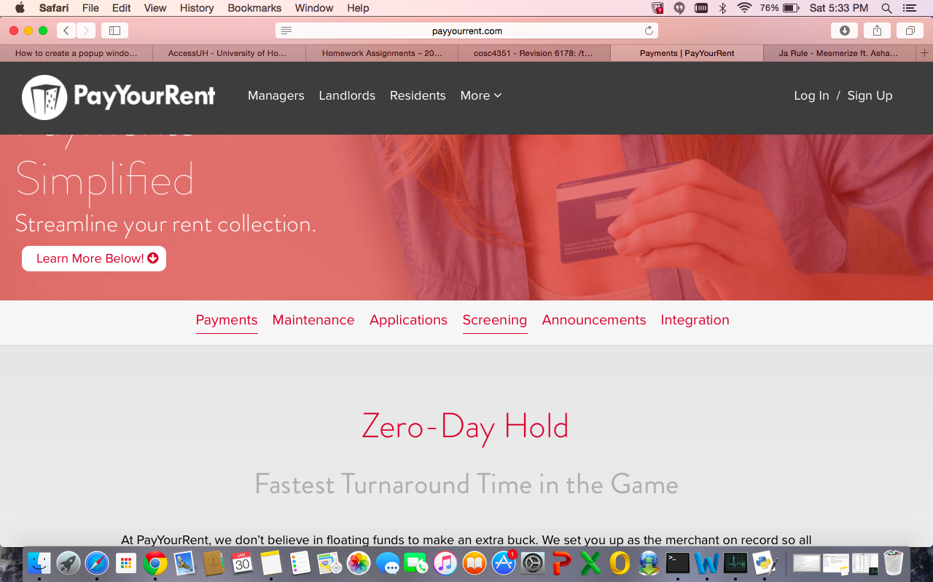  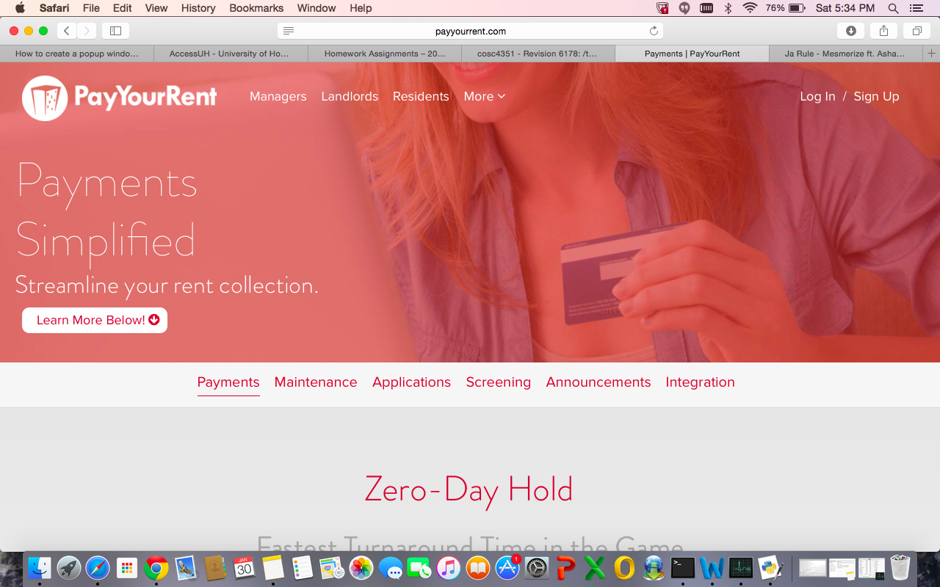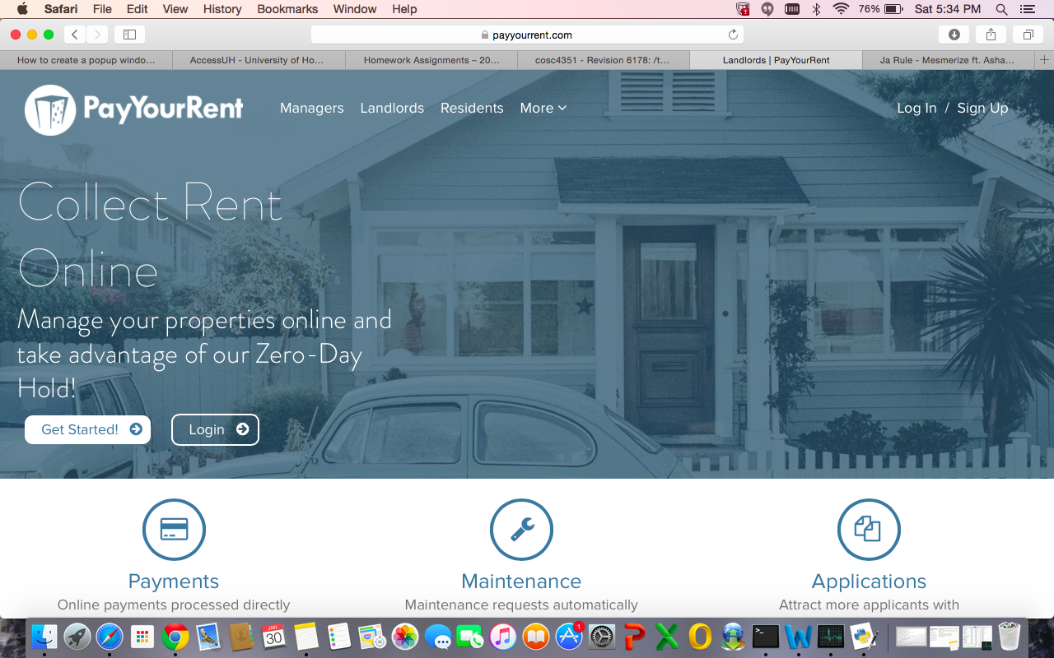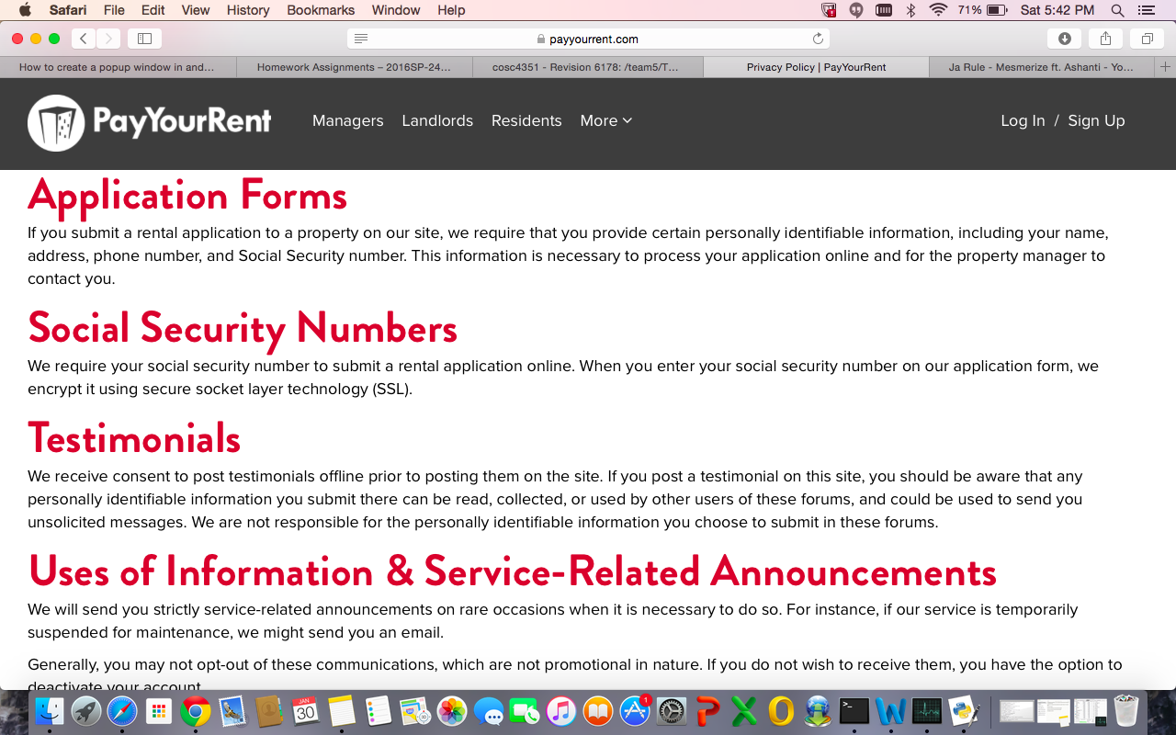
1.B |  | XX/XX/XXXX | I …..
1.C |  | XX/XX/XXXX | I …..
1.D |  | XX/XX/XXXX | I …..
1.E |  | XX/XX/XXXX | I …..
1.F |  | XX/XX/XXXX | I …..
1.G |  | XX/XX/XXXX | I …..
1.H |  | XX/XX/XXXX | I …..

Table 3: TL entry for RED DELIVERABLES (SVN Commit Comment matches Description)
Revision | Name | Due Date | Description
2.0 | Visak Varghese | XX/XX/XXXX | I changed Version to 2.0

Document Storage
This file is stored in SVN at https://svn.cs.uh.edu/svn/cosc4351/team5/TEAM PROJECT DELIVERABLES/Feasibility Study.doc.

